Truncated Polyhedra
# Source: AI Source: Provided by: [Data Path: Persons Table -> ID Column: 1, Name_En Column: Motasem Essam] -> From: [ChatGPT] on [7/25/2026]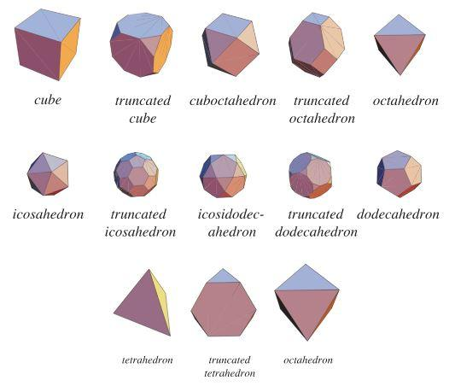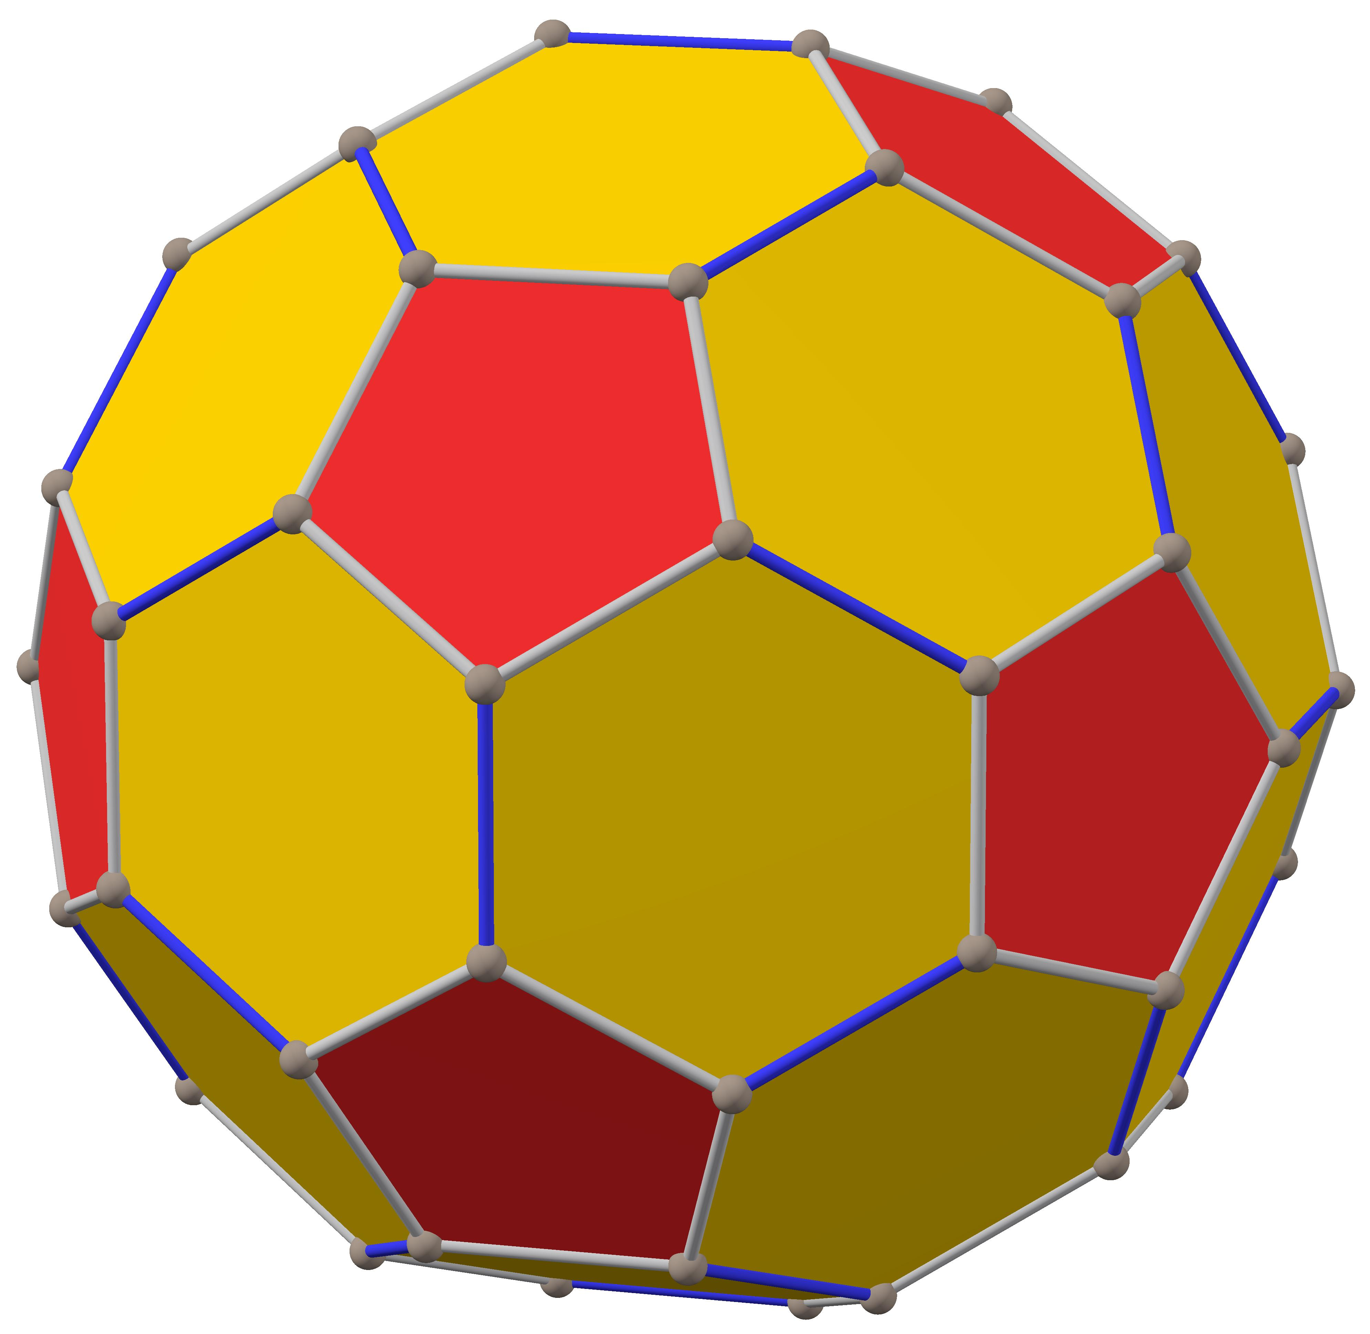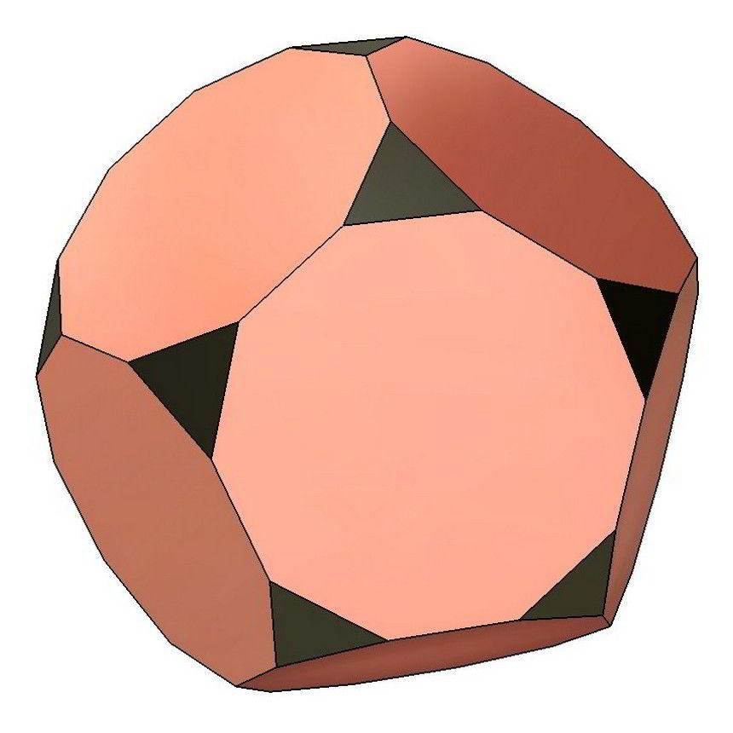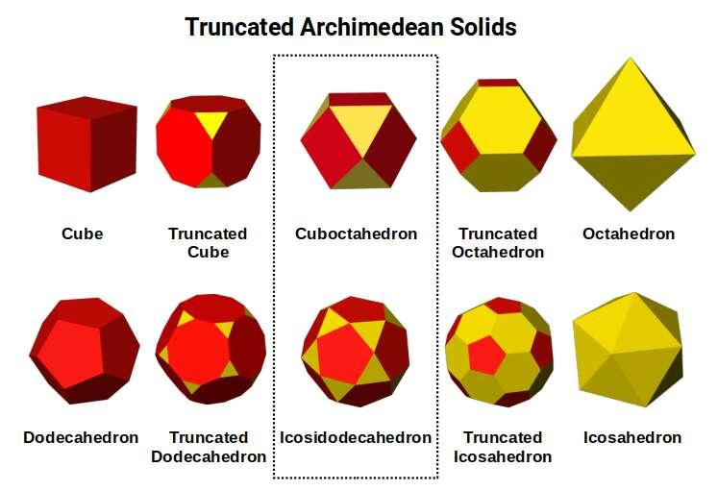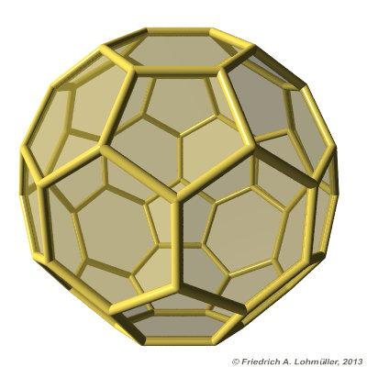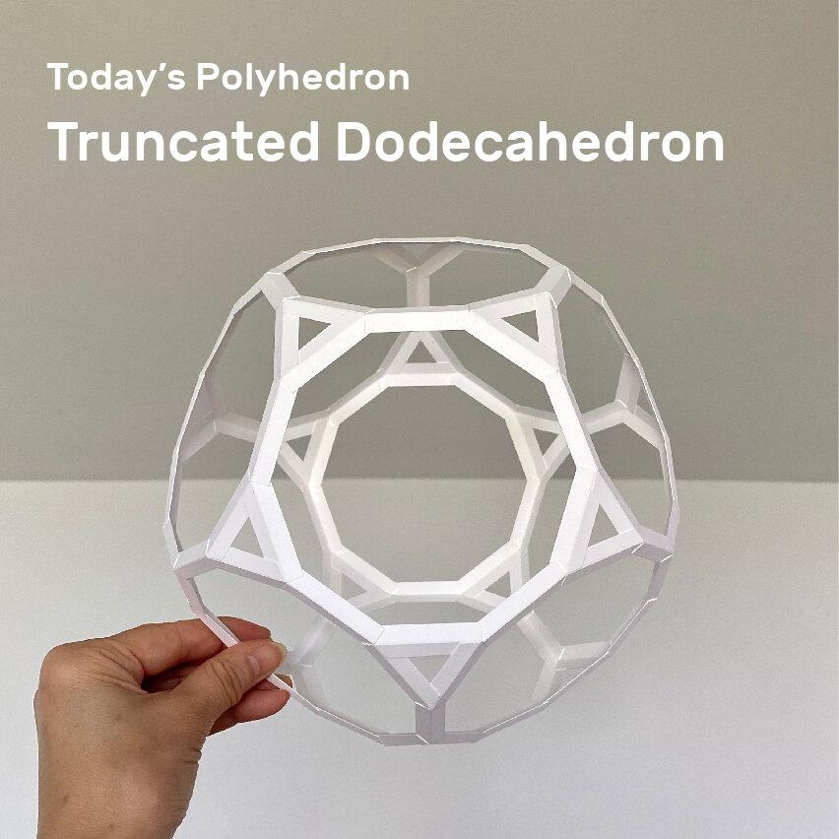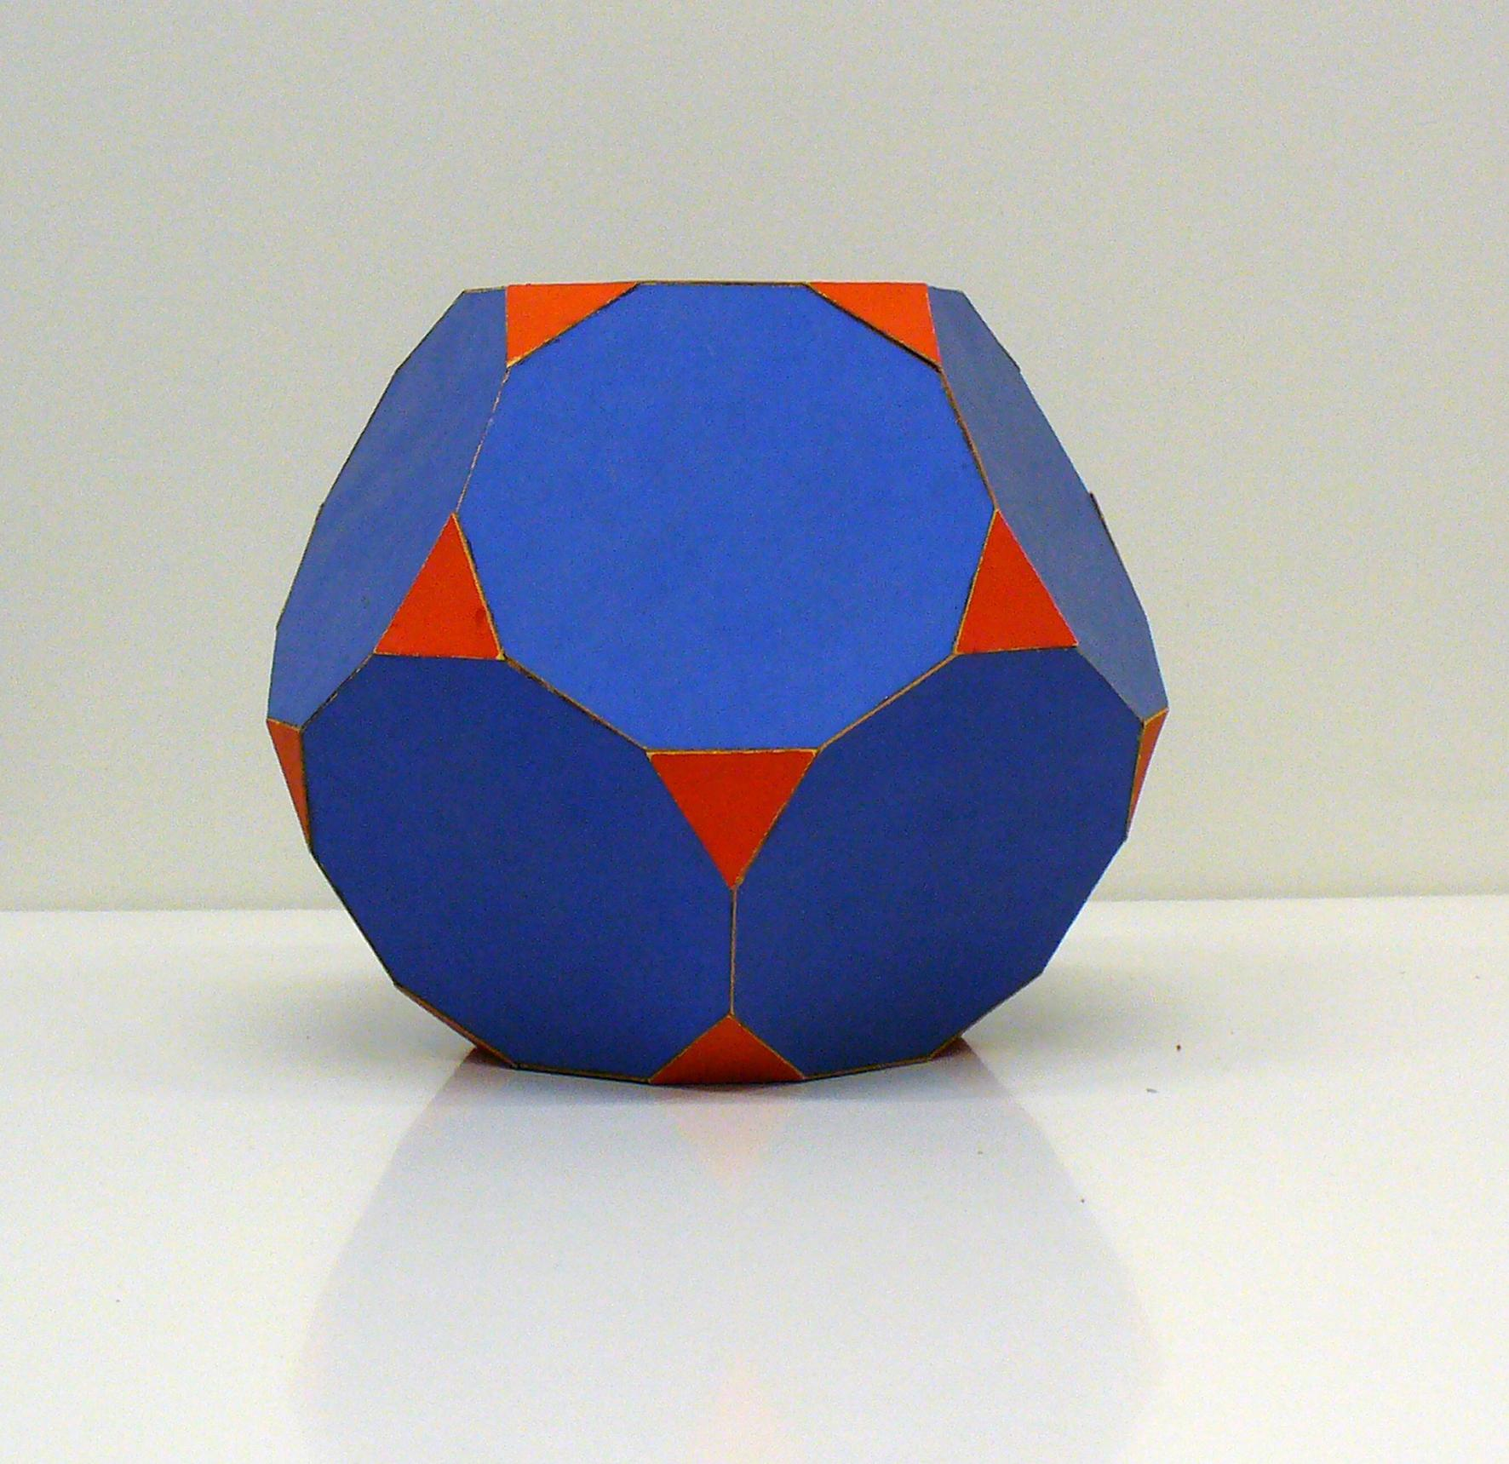

Definition
# Source: AI Source: Provided by: [Data Path: Persons Table -> ID Column: 1, Name_En Column: Motasem Essam] -> From: [ChatGPT] on [7/25/2026]
A Truncated Polyhedron is a three-dimensional polyhedron formed by cutting off one or more portions of an original polyhedron using planes.
The cutting process creates new polygonal faces called Truncation Faces, while modifying the original faces, edges, and vertices.
Truncation can be applied to regular, semiregular, and irregular polyhedra.

Simple Definition
# Source: AI Source: Provided by: [Data Path: Persons Table -> ID Column: 1, Name_En Column: Motasem Essam] -> From: [ChatGPT] on [7/25/2026]
A Truncated Polyhedron is a polyhedron created by cutting off vertices or other portions of an original polyhedron, producing new polygonal faces.

Geometric Structure
# Source: AI Source: Provided by: [Data Path: Persons Table -> ID Column: 1, Name_En Column: Motasem Essam] -> From: [ChatGPT] on [7/25/2026]
A truncated polyhedron generally consists of:
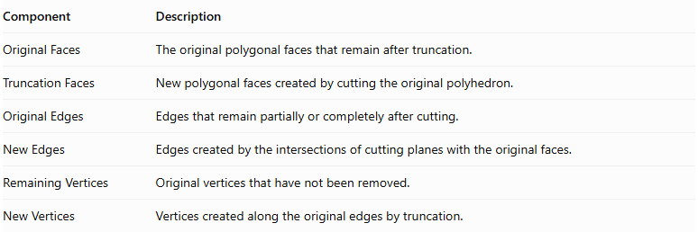
Component | Description
Original Faces | The original polygonal faces that remain after truncation.
Truncation Faces | New polygonal faces created by cutting the original polyhedron.
Original Edges | Edges that remain partially or completely after cutting.
New Edges | Edges created by the intersections of cutting planes with the original faces.
Remaining Vertices | Original vertices that have not been removed.
New Vertices | Vertices created along the original edges by truncation.
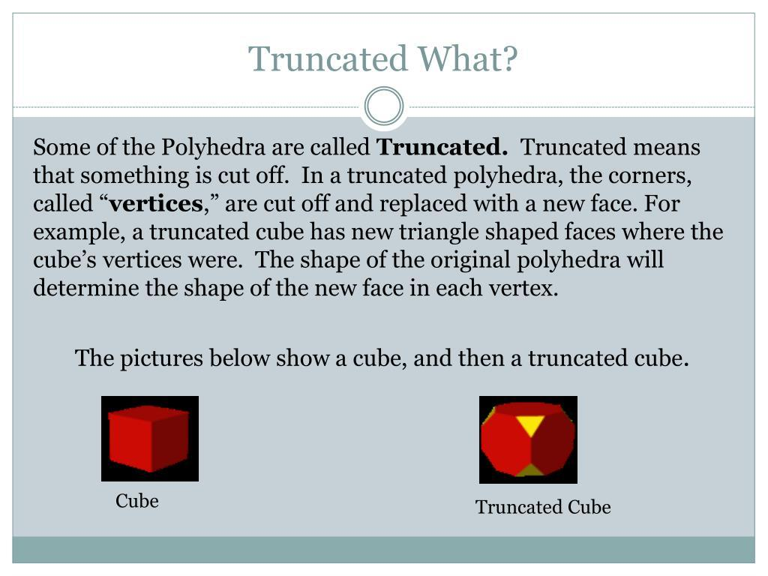

Truncation Process
# Source: AI Source: Provided by: [Data Path: Persons Table -> ID Column: 1, Name_En Column: Motasem Essam] -> From: [ChatGPT] on [7/25/2026]
The formation of a truncated polyhedron generally involves:
- Selecting an original polyhedron.
- Choosing one or more vertices or regions to truncate.
- Defining cutting planes around the selected regions.
- Removing the portions beyond the cutting planes.
- Obtaining new polygonal faces and a modified polyhedron.
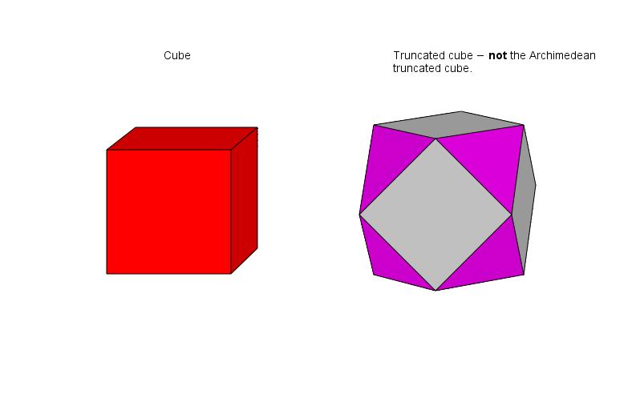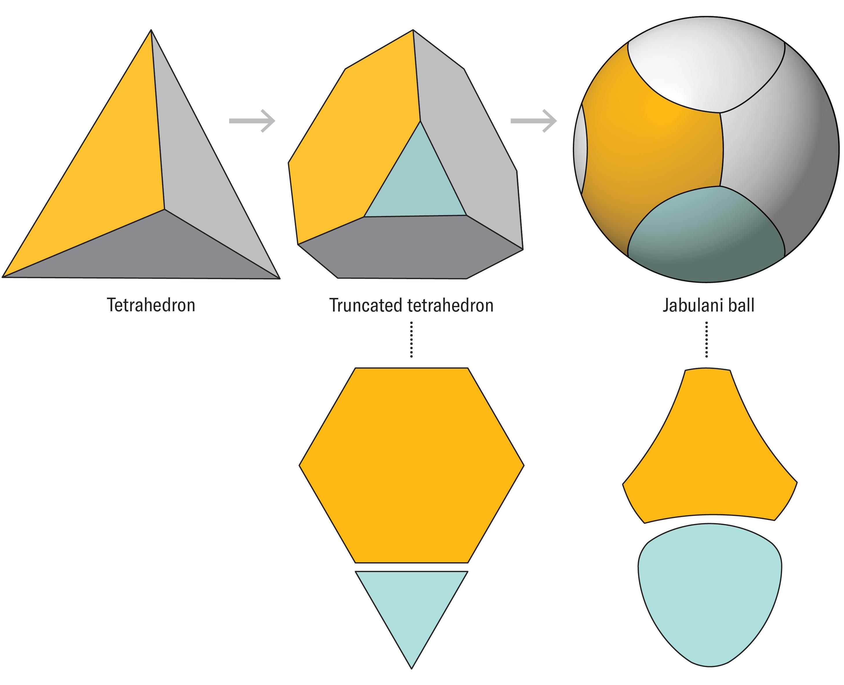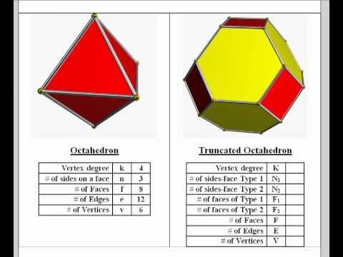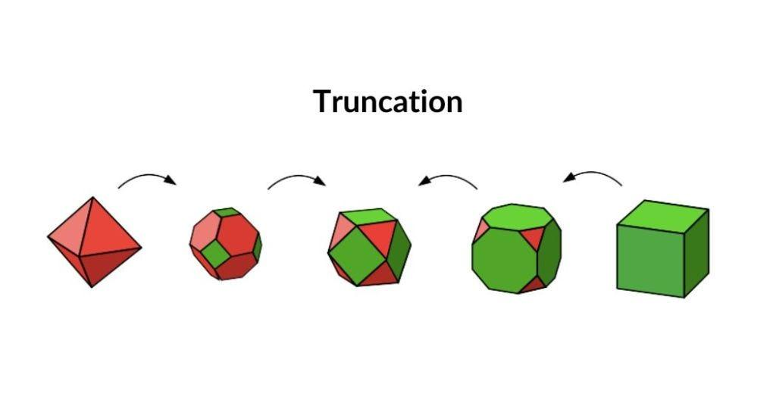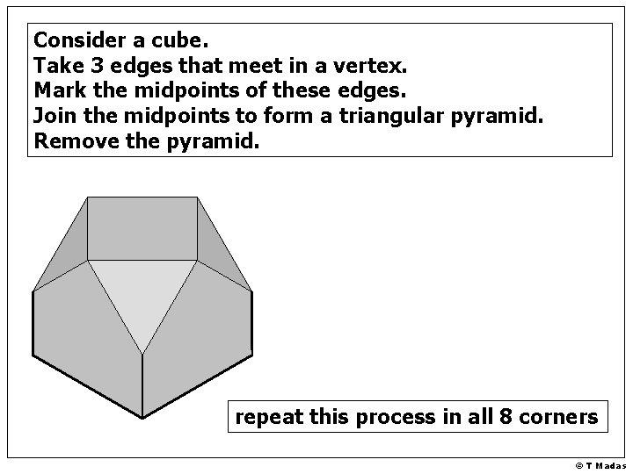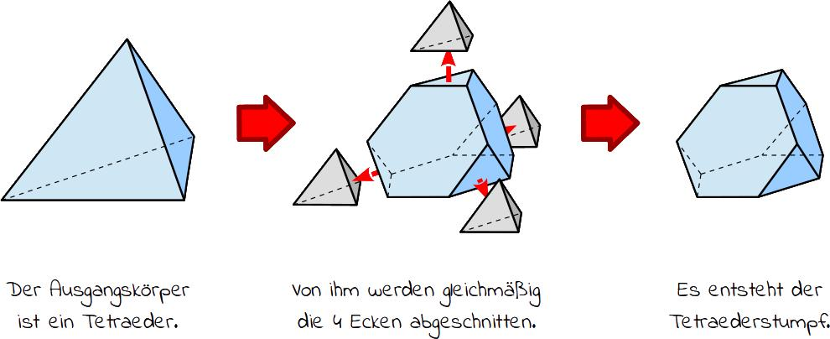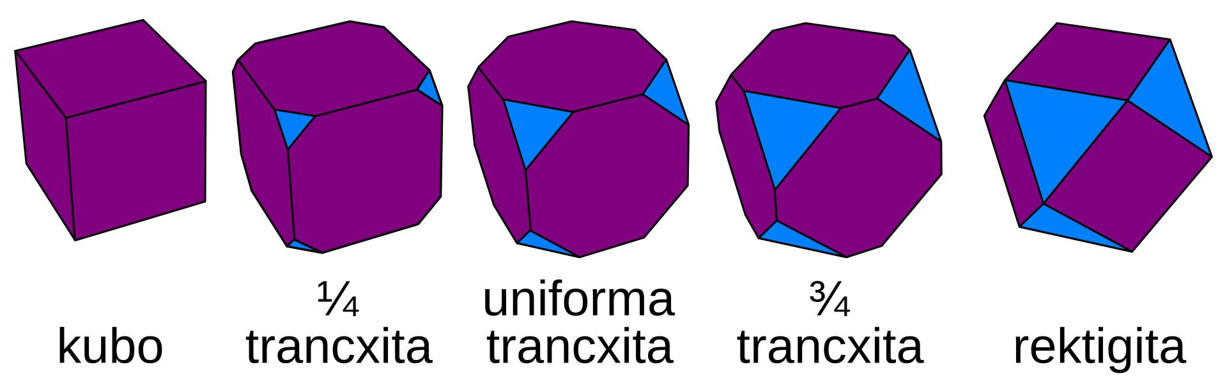

Types of Truncated Polyhedra
# Source: AI Source: Provided by: [Data Path: Persons Table -> ID Column: 1, Name_En Column: Motasem Essam] -> From: [ChatGPT] on [7/25/2026]
Truncated polyhedra can be classified according to the original polyhedron.

Truncated Platonic Solids
# Source: AI Source: Provided by: [Data Path: Persons Table -> ID Column: 1, Name_En Column: Motasem Essam] -> From: [ChatGPT] on [7/25/2026]
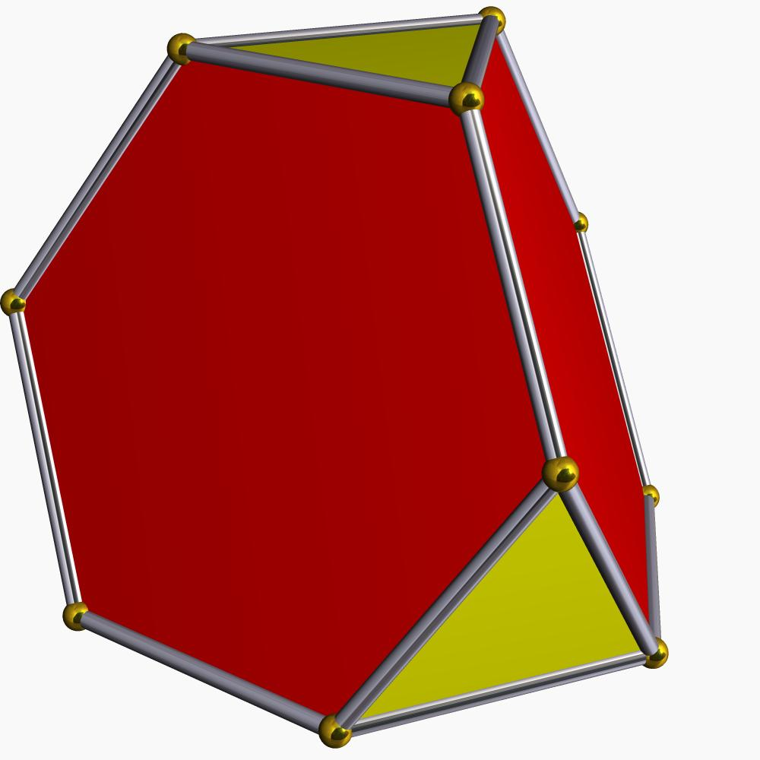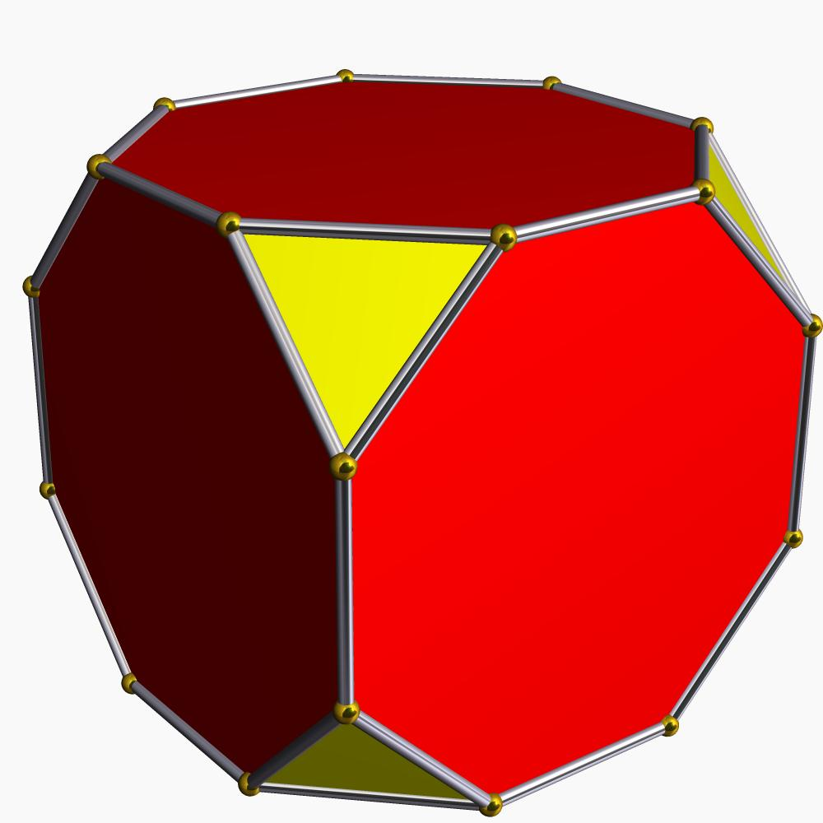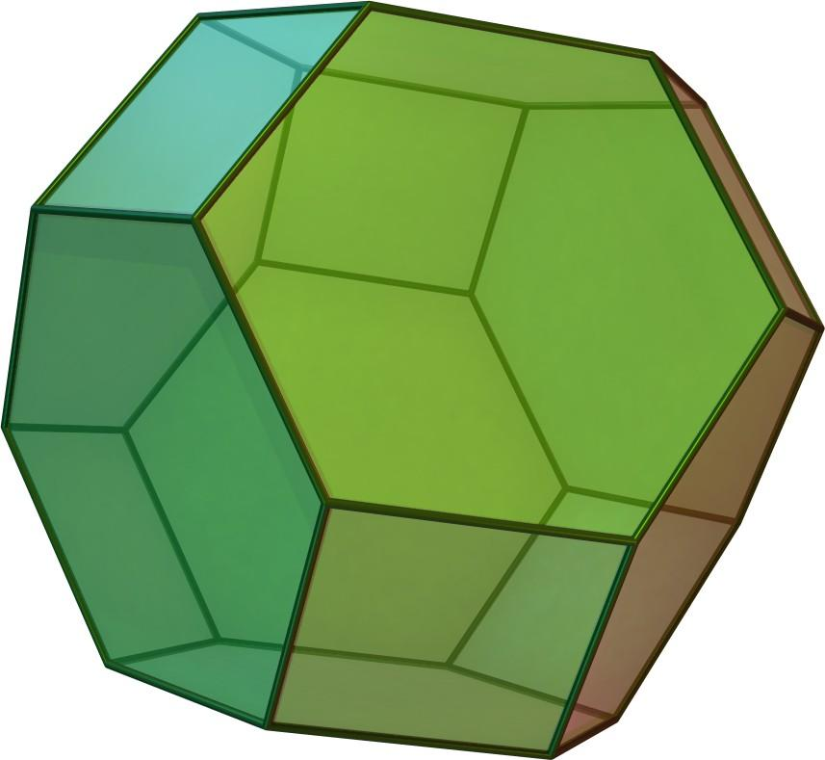
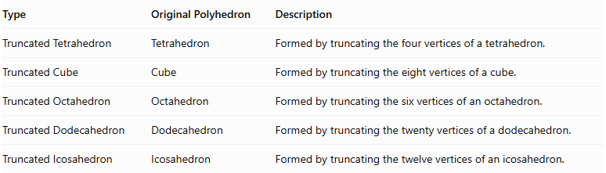
Type | Original Polyhedron | Description
Truncated Tetrahedron | Tetrahedron | Formed by truncating the four vertices of a tetrahedron.
Truncated Cube | Cube | Formed by truncating the eight vertices of a cube.
Truncated Octahedron | Octahedron | Formed by truncating the six vertices of an octahedron.
Truncated Dodecahedron | Dodecahedron | Formed by truncating the twenty vertices of a dodecahedron.
Truncated Icosahedron | Icosahedron | Formed by truncating the twelve vertices of an icosahedron.

Truncated Archimedean Solids
# Source: AI Source: Provided by: [Data Path: Persons Table -> ID Column: 1, Name_En Column: Motasem Essam] -> From: [ChatGPT] on [7/25/2026]
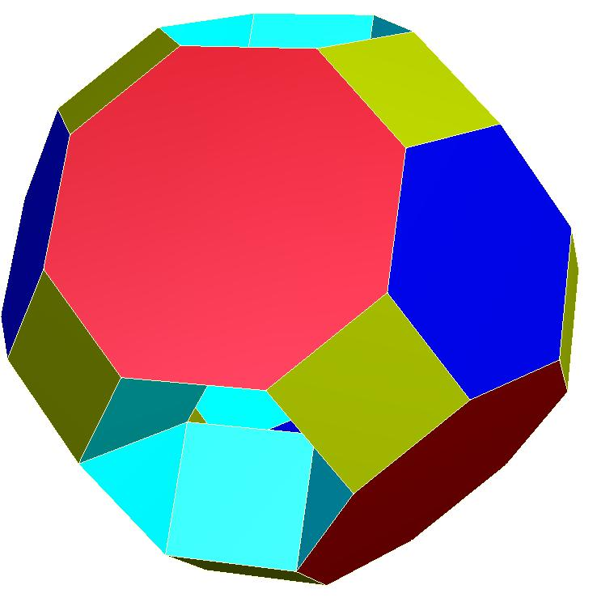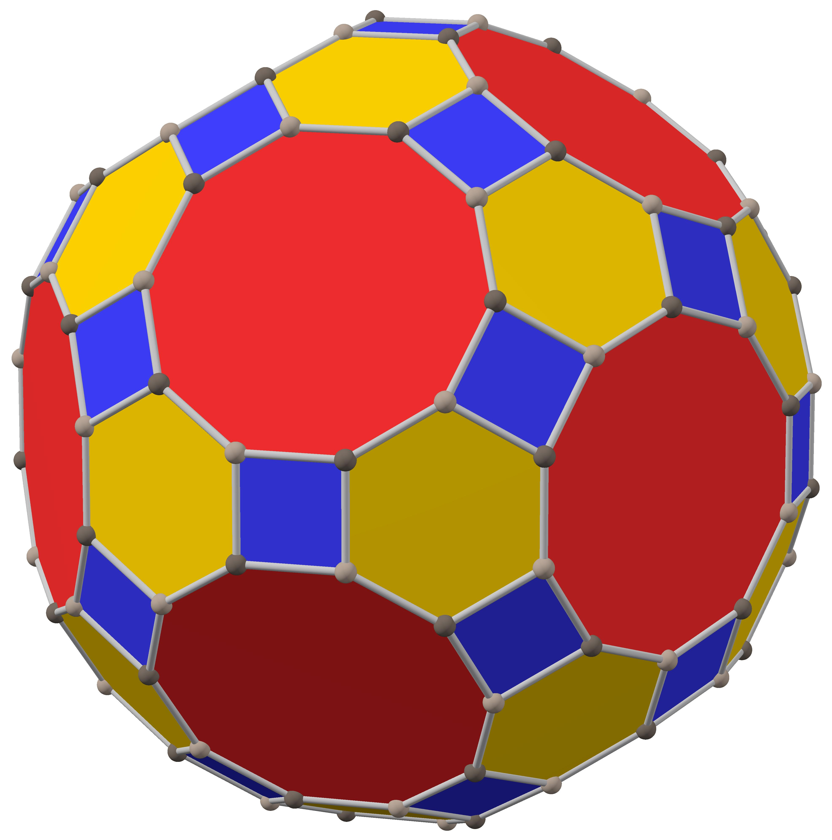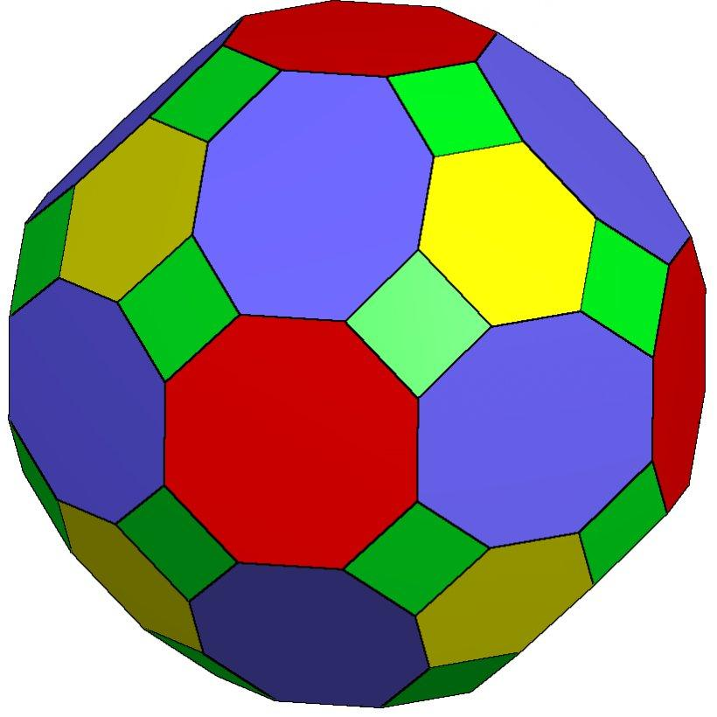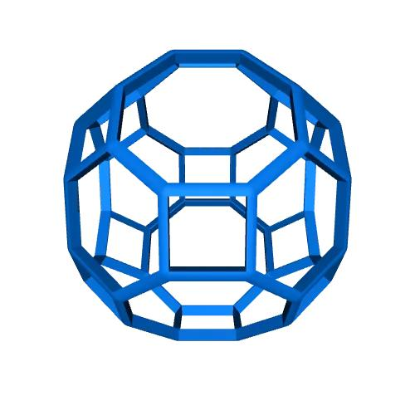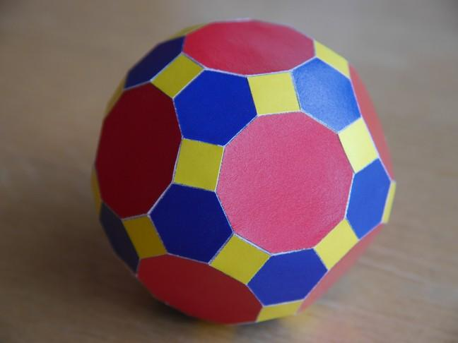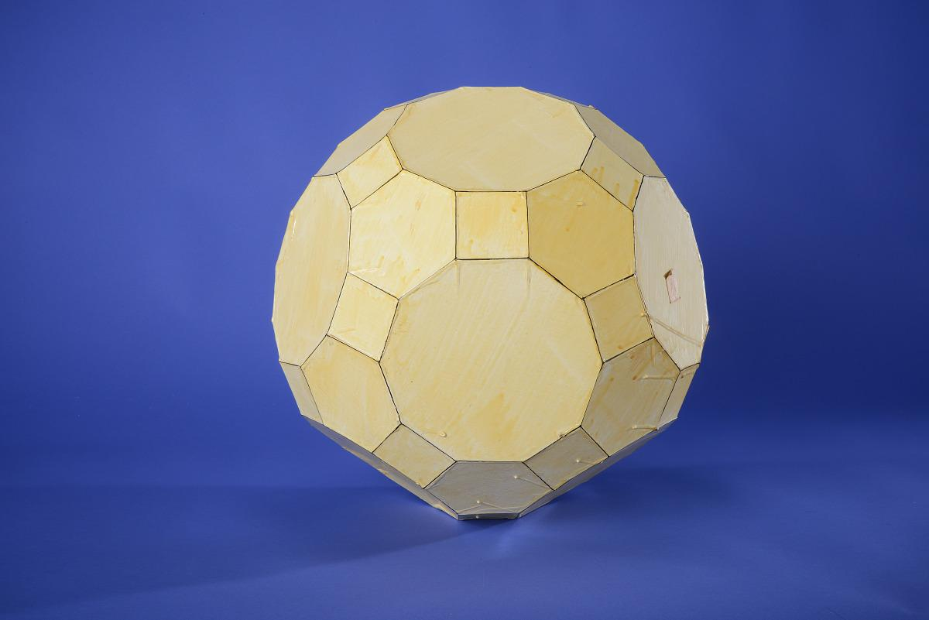
These are produced by truncating vertices of Archimedean solids or by applying related truncation operations to their structures.
Examples include:
- Truncated Cuboctahedron
- Truncated Icosidodecahedron
- Truncated Rhombicuboctahedron (a distinct Archimedean solid produced by truncating a cube's vertices in a particular construction).

Truncated Prisms and Antiprisms
# Source: AI Source: Provided by: [Data Path: Persons Table -> ID Column: 1, Name_En Column: Motasem Essam] -> From: [ChatGPT] on [7/25/2026]
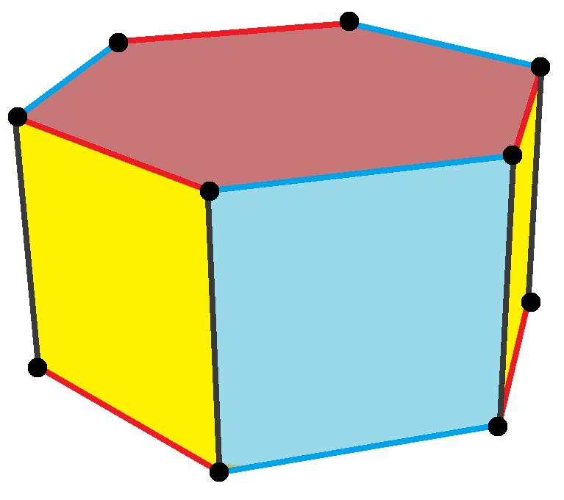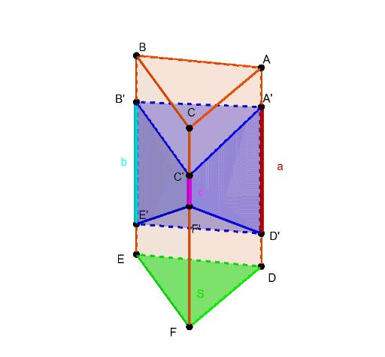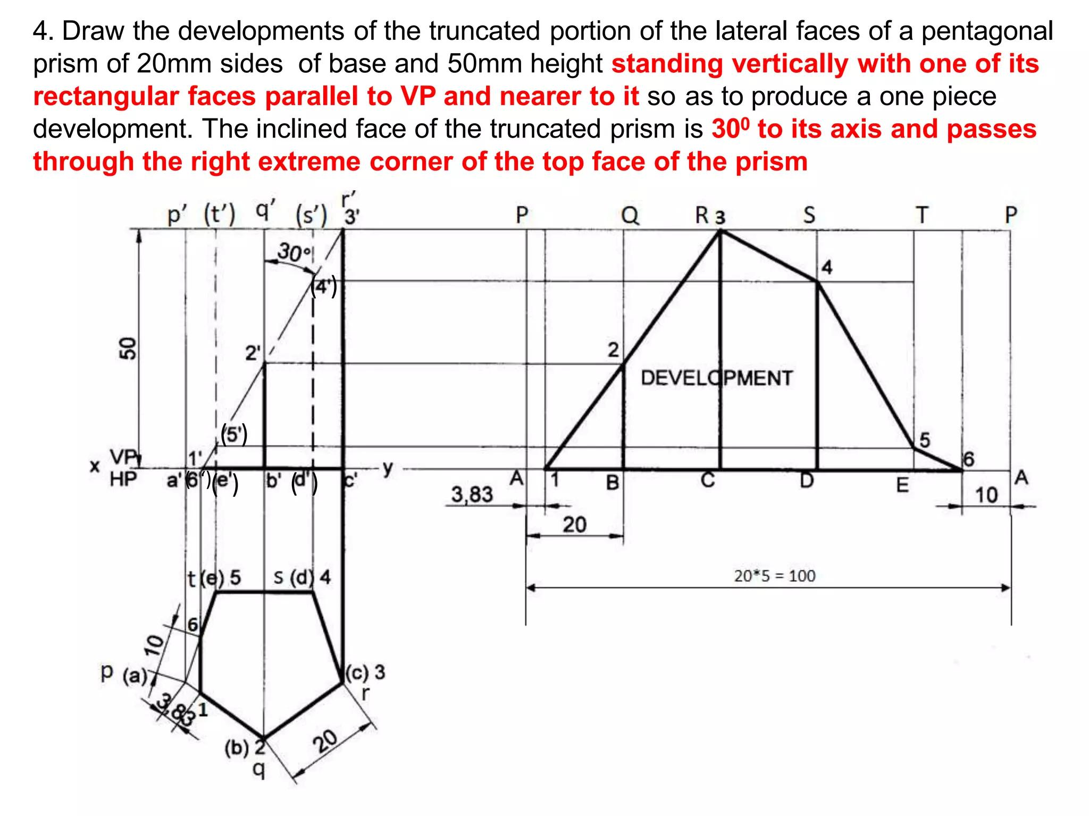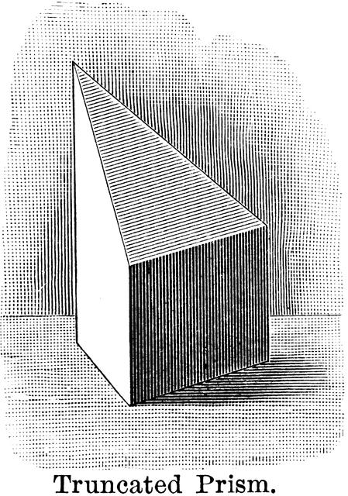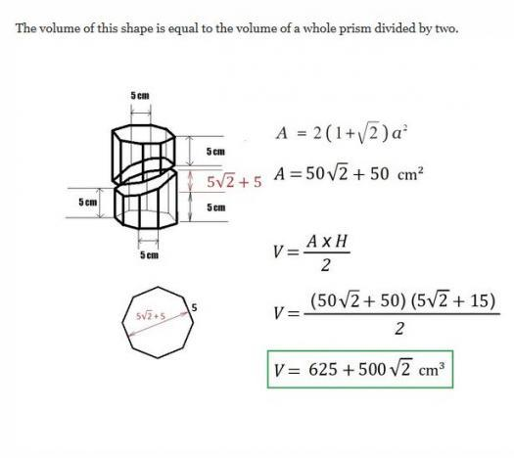
These are formed by cutting portions of prisms or antiprisms.
Examples:
- Truncated Triangular Prism
- Truncated Pentagonal Prism
- Truncated Hexagonal Prism
- Truncated Antiprism

Truncated Pyramidal Polyhedra
# Source: AI Source: Provided by: [Data Path: Persons Table -> ID Column: 1, Name_En Column: Motasem Essam] -> From: [ChatGPT] on [7/25/2026]
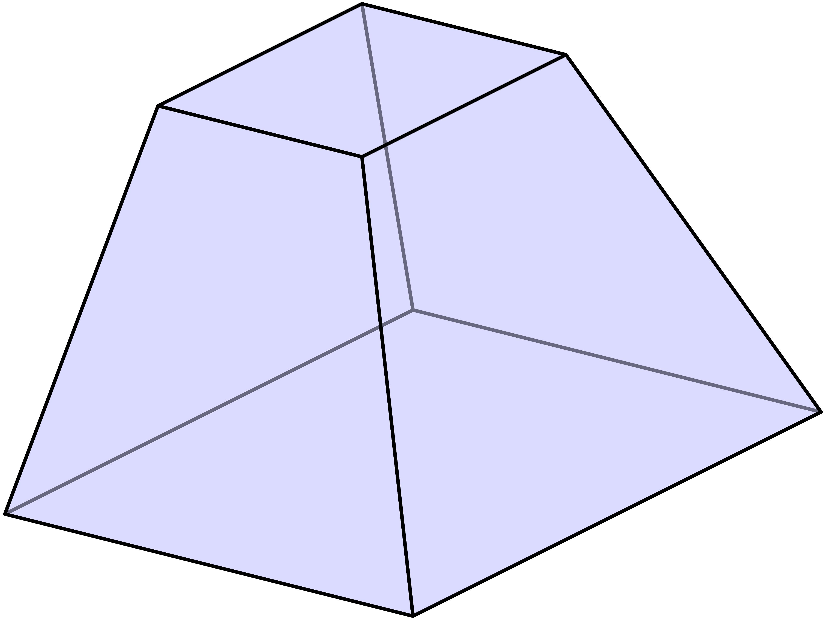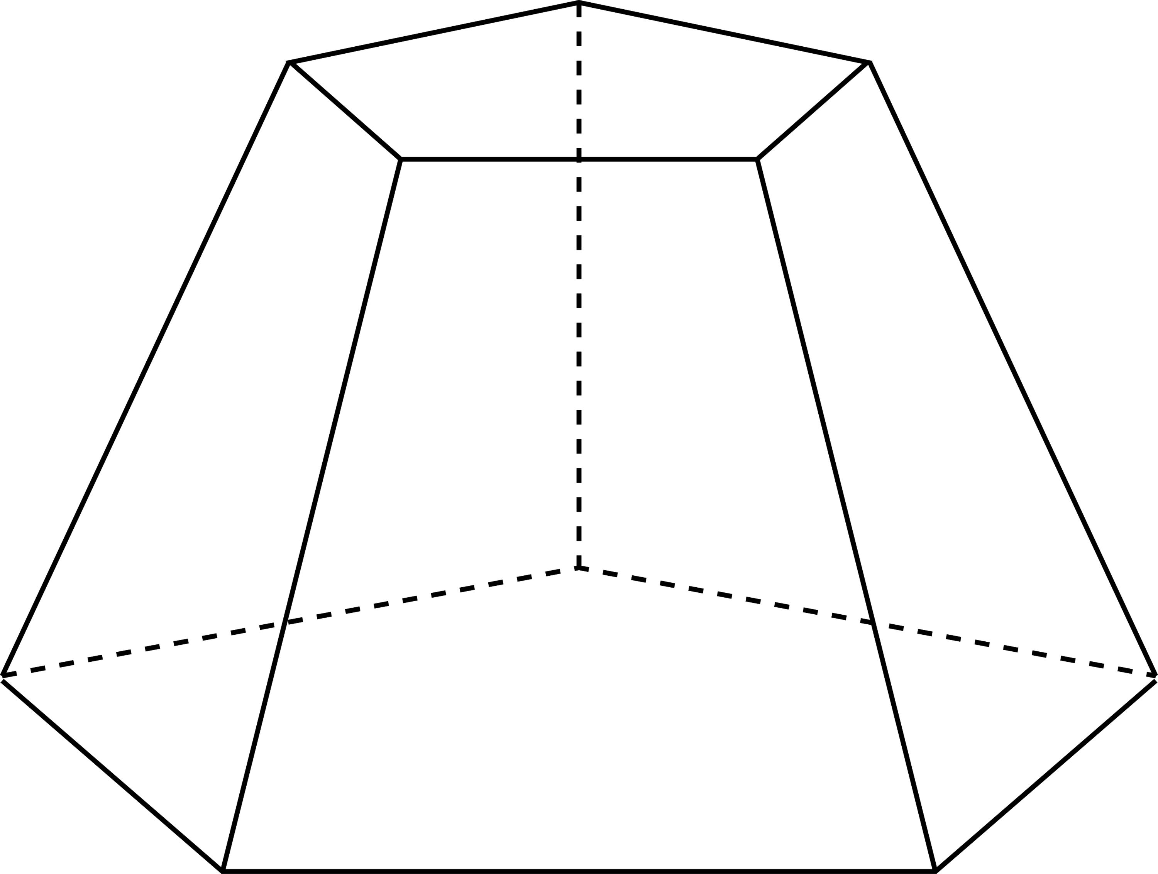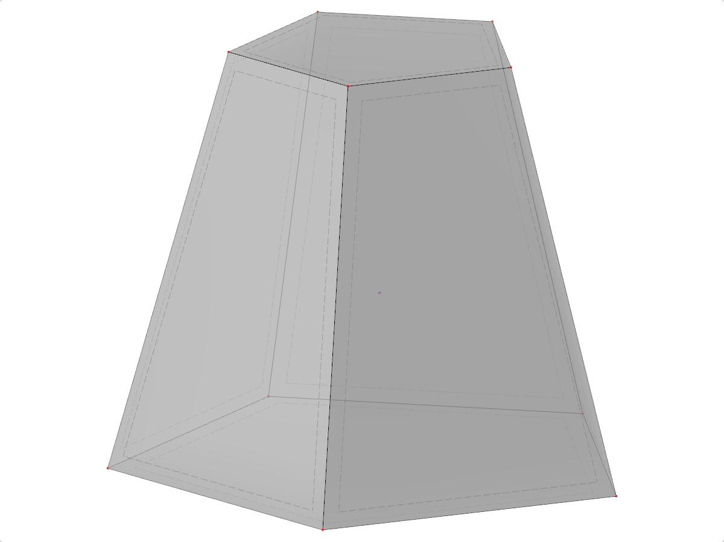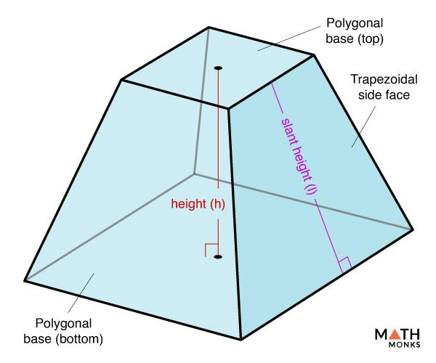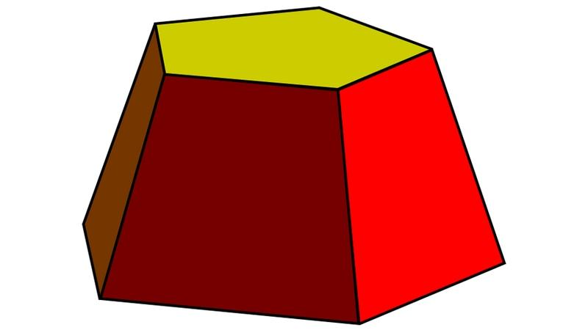
These are produced by cutting off the apex or other portions of pyramidal polyhedra.
Examples:
- Truncated Triangular Pyramid
- Truncated Square Pyramid
- Truncated Pentagonal Pyramid
- Truncated Hexagonal Pyramid

Types Based on Truncation Method

Vertex Truncation
# Source: AI Source: Provided by: [Data Path: Persons Table -> ID Column: 1, Name_En Column: Motasem Essam] -> From: [ChatGPT] on [7/25/2026]
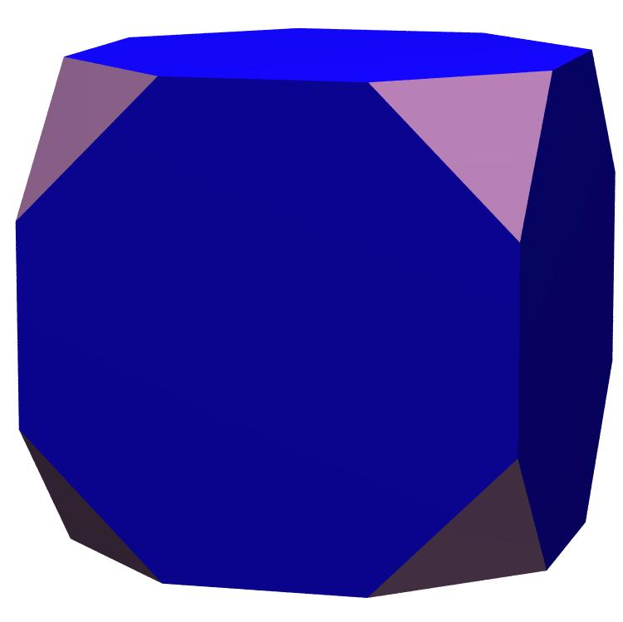
A Vertex-Truncated Polyhedron is formed by cutting off one or more vertices.
The cuts create new polygonal faces around the removed vertices.

Edge Truncation
# Source: AI Source: Provided by: [Data Path: Persons Table -> ID Column: 1, Name_En Column: Motasem Essam] -> From: [ChatGPT] on [7/25/2026]
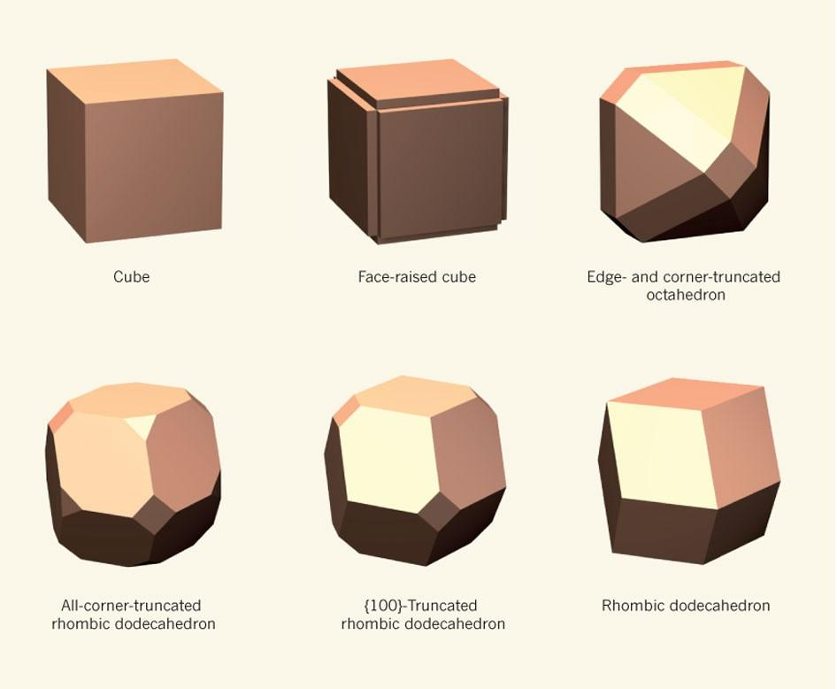
An Edge-Truncated Polyhedron is formed by removing portions around selected edges.
Depending on the construction, the operation can create additional faces and modify adjacent vertices.

Face Truncation
# Source: AI Source: Provided by: [Data Path: Persons Table -> ID Column: 1, Name_En Column: Motasem Essam] -> From: [ChatGPT] on [7/25/2026]
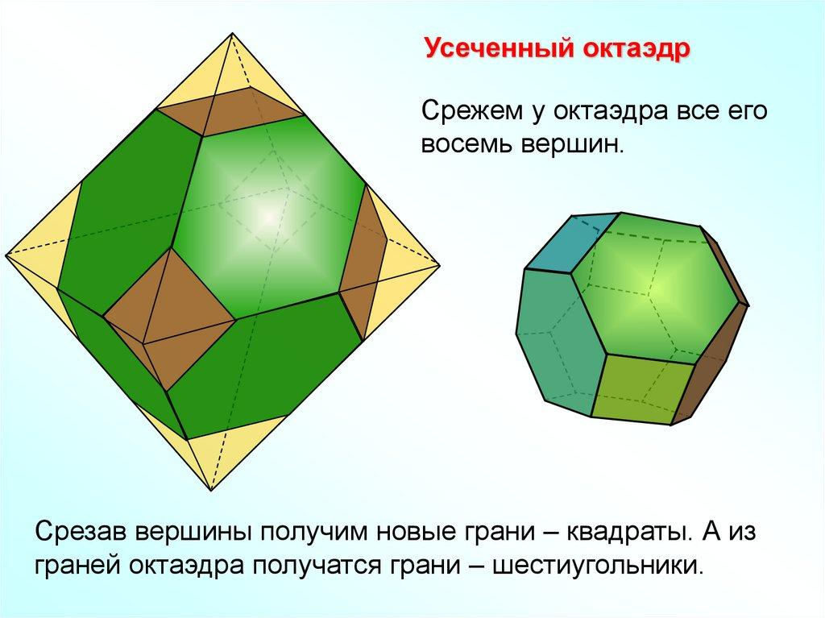
A Face-Truncated Polyhedron is formed by removing a portion of the solid through a cut associated with one or more faces.
This is a descriptive construction category rather than a single standardized polyhedron operation.

Uniform Truncation
# Source: AI Source: Provided by: [Data Path: Persons Table -> ID Column: 1, Name_En Column: Motasem Essam] -> From: [ChatGPT] on [7/25/2026]
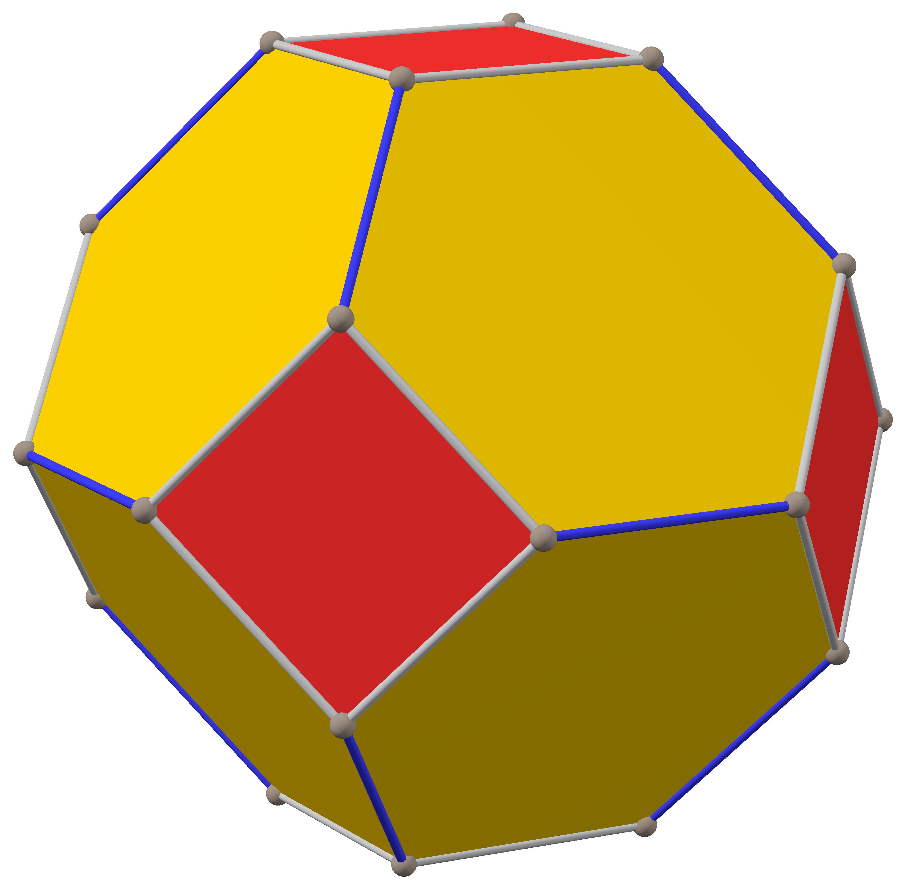
A Uniformly Truncated Polyhedron is produced by applying equivalent truncations consistently to all equivalent vertices of a symmetric polyhedron.
When applied appropriately to a regular polyhedron, this can produce a uniform polyhedron with regular polygonal faces and equivalent vertex arrangements.

Mathematical Properties
# Source: AI Source: Provided by: [Data Path: Persons Table -> ID Column: 1, Name_En Column: Motasem Essam] -> From: [ChatGPT] on [7/25/2026]
The number of faces, edges, and vertices depends on the original polyhedron and the truncation method.
For a convex polyhedron:
$$V-E+F=2$$
where:
- $V$ = number of vertices.
- $E$ = number of edges.
- $F$ = number of faces.
Example: Uniform Vertex Truncation
For a convex polyhedron with:
- $V$ original vertices.
- $E$ original edges.
- $F$ original faces.
If every original vertex is truncated by a plane that intersects all incident edges, without overlapping cuts, then:
$$V'=2E$$
$$E'=3E$$
$$F'=F+V$$
Here, each original edge receives two new vertices, and each original vertex produces one new truncation face.
These formulas assume that every original vertex is truncated and that the resulting solid remains a convex polyhedron.

Examples of Face, Edge, and Vertex Counts
# Source: AI Source: Provided by: [Data Path: Persons Table -> ID Column: 1, Name_En Column: Motasem Essam] -> From: [ChatGPT] on [7/25/2026]
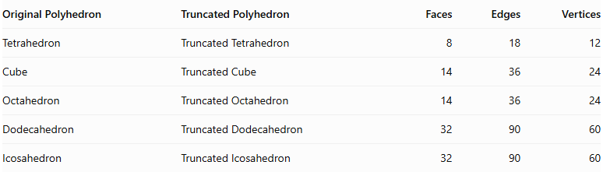
Original Polyhedron | Truncated Polyhedron | Faces | Edges | Vertices
Tetrahedron | Truncated Tetrahedron | 8 | 18 | 12
Cube | Truncated Cube | 14 | 36 | 24
Octahedron | Truncated Octahedron | 14 | 36 | 24
Dodecahedron | Truncated Dodecahedron | 32 | 90 | 60
Icosahedron | Truncated Icosahedron | 32 | 90 | 60
These counts refer to the standard uniform vertex-truncated forms.

Surface Area and Volume
# Source: AI Source: Provided by: [Data Path: Persons Table -> ID Column: 1, Name_En Column: Motasem Essam] -> From: [ChatGPT] on [7/25/2026]
There is no single universal formula for every truncated polyhedron.
Volume
The remaining volume is:
$$V_{remaining}=V_{original}-V_{removed}$$
If multiple portions are removed:
$$V_{remaining}=V_{original}-\sum_{i=1}^{k}{V_{removed,i}}$$
where $k$ is the number of removed portions.
Surface Area
The surface area is the sum of all remaining original polygonal faces and all newly created truncation faces:
$${SA}_{truncated}=\sum{A_{remaining faces}}+\sum{A_{new faces}}$$

Symmetry
# Source: AI Source: Provided by: [Data Path: Persons Table -> ID Column: 1, Name_En Column: Motasem Essam] -> From: [ChatGPT] on [7/25/2026]
The symmetry of a truncated polyhedron depends on the original polyhedron and the truncation method.
For uniform truncation of a regular polyhedron:
- The original rotational symmetries are generally preserved.
- The original reflection symmetries are generally preserved.
- The resulting polyhedron may have regular polygonal faces.
- Its symmetry group is inherited from the original polyhedron when all equivalent vertices are truncated equally.

Relationship to Other Solids
# Source: AI Source: Provided by: [Data Path: Persons Table -> ID Column: 1, Name_En Column: Motasem Essam] -> From: [ChatGPT] on [7/25/2026]
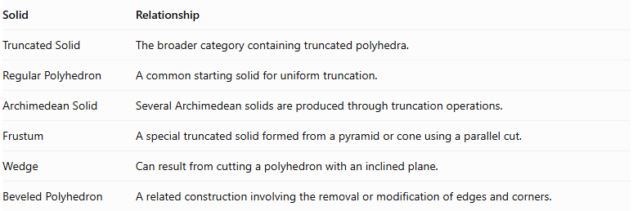
Solid | Relationship
Truncated Solid | The broader category containing truncated polyhedra.
Regular Polyhedron | A common starting solid for uniform truncation.
Archimedean Solid | Several Archimedean solids are produced through truncation operations.
Frustum | A special truncated solid formed from a pyramid or cone using a parallel cut.
Wedge | Can result from cutting a polyhedron with an inclined plane.
Beveled Polyhedron | A related construction involving the removal or modification of edges and corners.

Key Points
# Source: AI Source: Provided by: [Data Path: Persons Table -> ID Column: 1, Name_En Column: Motasem Essam] -> From: [ChatGPT] on [7/25/2026]
- A truncated polyhedron is formed by cutting portions from an original polyhedron.
- The new faces are called truncation faces.
- Truncation can modify vertices, edges, and faces.
- Truncation can be applied to Platonic and Archimedean solids.
- Uniform vertex truncation preserves the symmetry of a regular starting polyhedron.
- The resulting face shapes depend on the original polyhedron and the truncation method.
- Euler's formula remains valid for a closed convex truncated polyhedron.

Conclusion
# Source: AI Source: Provided by: [Data Path: Persons Table -> ID Column: 1, Name_En Column: Motasem Essam] -> From: [ChatGPT] on [7/25/2026]
A Truncated Polyhedron is a modified polyhedron created by removing portions of an original polyhedron through planar cuts. It forms an important category of solid geometry because it includes many well-known geometric solids, particularly the truncated Platonic solids and several Archimedean solids.
Classification note: For your Solid Geometry taxonomy, the recommended folder structure is:
Truncated Solids
└── Truncated Polyhedra
├── Truncated Platonic Solids
├── Truncated Archimedean Solids
├── Truncated Prisms and Antiprisms
├── Truncated Pyramidal Polyhedra
└── Types Based on Truncation Method
├── Vertex Truncation
├── Edge Truncation
├── Face Truncation
└── Uniform Truncation

